Placement Eligibility and Resume Screening Portal :

DATABASE:

CREATE DATABASE placement_portal;

SHOW DATABASES;

USE placement_portal;

CREATE TABLE students (
student_id INT AUTO_INCREMENT PRIMARY KEY,
name VARCHAR(100) NOT NULL,
email VARCHAR(100) UNIQUE NOT NULL,
password VARCHAR(255) NOT NULL,
department VARCHAR(50) NOT NULL,
cgpa DECIMAL(4,2),
passing_year YEAR NOT NULL,
backlogs INT DEFAULT 0,
semester INT,
phone VARCHAR(15),
skills VARCHAR(255),
created_at TIMESTAMP DEFAULT CURRENT_TIMESTAMP,
CHECK (cgpa >= 0 AND cgpa <= 10)
);

CREATE TABLE faculty (
faculty_id INT AUTO_INCREMENT PRIMARY KEY,
name VARCHAR(100) NOT NULL,
email VARCHAR(100) UNIQUE NOT NULL,
password VARCHAR(255) NOT NULL,
role ENUM('PLACEMENT_OFFICER', 'FACULTY') NOT NULL,
department VARCHAR(50),
phone VARCHAR(15),
created_at TIMESTAMP DEFAULT CURRENT_TIMESTAMP
);

CREATE TABLE company (
company_id INT AUTO_INCREMENT PRIMARY KEY,
company_name VARCHAR(100) NOT NULL,
industry_type VARCHAR(50),
hr_name VARCHAR(100) NOT NULL,
hr_email VARCHAR(100) UNIQUE NOT NULL,
hr_password VARCHAR(255) NOT NULL,
hr_phone VARCHAR(15),
job_profile VARCHAR(100),
salary_package DECIMAL(10,2),
recruitment_schedule DATE,
is_active BOOLEAN DEFAULT TRUE,
created_at TIMESTAMP DEFAULT CURRENT_TIMESTAMP
);

CREATE TABLE eligibility (
eligibility_id INT AUTO_INCREMENT PRIMARY KEY,
company_id INT NOT NULL,
min_cgpa DECIMAL(4,2) NOT NULL,
max_backlogs INT DEFAULT 0,
department VARCHAR(255),
passing_year YEAR NOT NULL,
required_skills VARCHAR(255),
created_by INT NOT NULL,
is_active BOOLEAN DEFAULT TRUE,
created_at TIMESTAMP DEFAULT CURRENT_TIMESTAMP,

FOREIGN KEY (company_id)
REFERENCES company(company_id),

FOREIGN KEY (created_by)
REFERENCES faculty(faculty_id)
);

INSERT INTO students
(name, email, password, department, cgpa, passing_year, backlogs, semester, phone, skills)
VALUES
('Aarav Sharma', 'aarav@gmail.com', 'pass123', 'CSE', 8.50, 2027, 0, 5, '9876543210', 'Java,SQL,Python'),
('Priya Patil', 'priya@gmail.com', 'pass123', 'IT', 7.80, 2027, 0, 5, '9876543211', 'Java,React,SQL'),
('Rohan Mehta', 'rohan@gmail.com', 'pass123', 'ECE', 7.20, 2026, 1, 7, '9876543212', 'Python,C,Embedded'),
('Sneha Joshi', 'sneha@gmail.com', 'pass123', 'CSE', 9.10, 2027, 0, 5, '9876543213', 'Java,Python,Machine Learning'),
('Vivek Shah', 'vivek@gmail.com', 'pass123', 'IT', 6.90, 2027, 2, 5, '9876543214', 'HTML,CSS,JavaScript');

SELECT * FROM students;

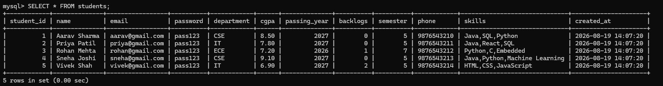

INSERT INTO faculty
(name, email, password, role, department, phone)
VALUES
('Amit Kulkarni', 'amit@college.com', 'pass123', 'PLACEMENT_OFFICER', 'CSE', '9876500001'),
('Neha Deshmukh', 'neha@college.com', 'pass123', 'PLACEMENT_OFFICER', 'IT', '9876500002'),
('Rajesh Patil', 'rajesh@college.com', 'pass123', 'FACULTY', 'CSE', '9876500003'),
('Pooja Joshi', 'pooja@college.com', 'pass123', 'FACULTY', 'ECE', '9876500004'),
('Sanjay More', 'sanjay@college.com', 'pass123', 'FACULTY', 'IT', '9876500005');

SELECT * FROM faculty;

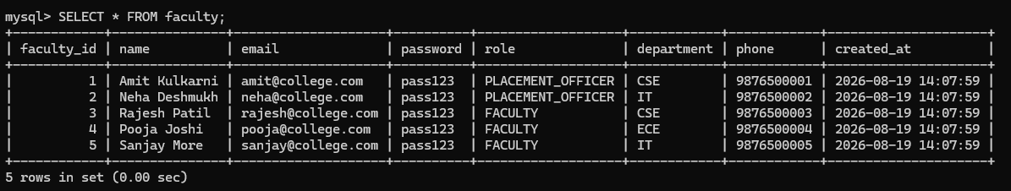

INSERT INTO company
(company_name, industry_type, hr_name, hr_email, hr_password, hr_phone, job_profile, salary_package, recruitment_schedule)
VALUES
('TCS', 'IT', 'Anita Rao', 'anita@tcs.com', 'pass123', '9000000001', 'Software Engineer', 600000.00, '2026-09-15'),

('Infosys', 'IT', 'Rahul Verma', 'rahul@infosys.com', 'pass123', '9000000002', 'Systems Engineer', 550000.00, '2026-09-20'),

('Accenture', 'Consulting', 'Kavita Shah', 'kavita@accenture.com', 'pass123', '9000000003', 'Associate Software Engineer', 650000.00, '2026-09-25'),

('Deloitte', 'Consulting', 'Vikas Mehta', 'vikas@deloitte.com', 'pass123', '9000000004', 'Analyst', 700000.00, '2026-10-05'),

('Wipro', 'IT', 'Sneha Kapoor', 'sneha@wipro.com', 'pass123', '9000000005', 'Project Engineer', 500000.00, '2026-10-10');

SELECT * FROM company;

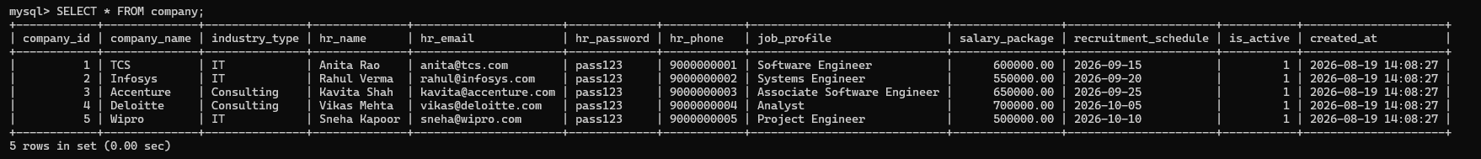

INSERT INTO eligibility
(company_id, min_cgpa, max_backlogs, department, passing_year, required_skills, created_by)
VALUES
(1, 7.50, 0, 'CSE,IT', 2027, 'Java,SQL', 1),

(2, 7.00, 1, 'CSE,IT,ECE', 2027, 'Python,SQL', 2),

(3, 7.50, 0, 'CSE,IT', 2027, 'Java,Python', 1),

(4, 8.00, 0, 'CSE,IT', 2027, 'Python,SQL,Excel', 3),

(5, 6.50, 2, 'CSE,IT,ECE', 2027, 'Java,HTML,CSS', 4);

SELECT * FROM eligibility;
